Chapter 19, Solution 49.

To get 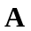 and 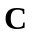, refer to the circuit in Fig.(a).
1 
1/s
1/s
+
−
(a)

I₁
+
V₂
−
V₁
I₂ = 0
1/s
1 
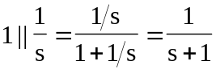

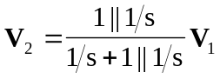

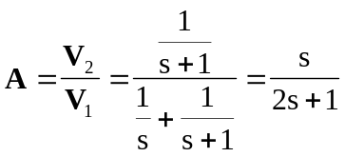

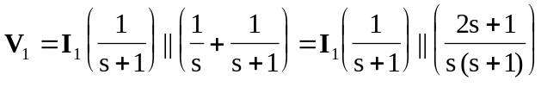

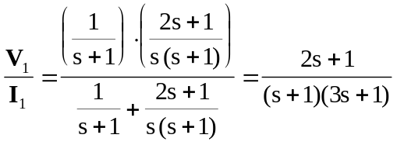

But 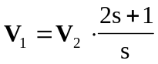
Hence, 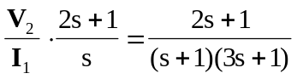

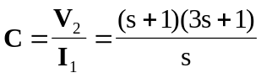

To get 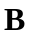 and , consider the circuit in Fig. (b).
1 
1/s
1/s
+
−
(b)

I₁
V₁
1/s
1 
I₂
+
V₂ = 0
−

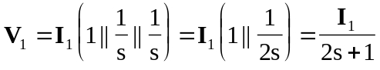

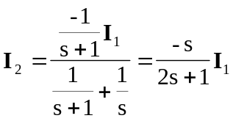

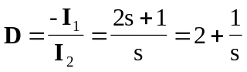

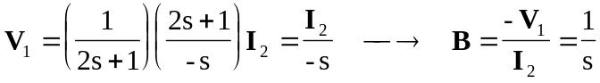

Thus,
